**TECHNICAL REPORT**

ON

**STUDENT INDUSTRIAL WORK EXPERIENCE SCHEME**

**(SIWES)**

PREPARED BY

**IMOHIOSEN DANIEL OISEOJE**

**MATRIC NO: 16CD004610**

DEPARTMENT OF COMPUTER SCIENCE,

COLLEGE OF PURE AND APPLIED SCIENCES,

LANDMARK UNIVERSITY, OMU-ARAN, KWARA STATE

UNDERTAKEN AT



ENCENTRAL SOLUTIONS LTD

PLOT 856 OLU AWOTESU STREET, JABI ABUJA.

**IN PARTIAL FULFILMENT OF THE REQUIREMENTS FOR THE AWARD OF BACHELOR OF SCIENCE IN COMPUTER SCIENCE**

SUPERVISOR: DR BABAFEMI GBADAMOSI

**SEPTEMBER 2019.**

**DECLARATION**

I, **IMOHIOSEN DANIEL OISEOJE**, hereby declare that this SIWES Report has been carried out by me under the supervision of Mr. James Akinniranye. It has not been presented for award of any degree in any institution. All sources of information are specially acknowledged by means of reference.

……………………… ………………………  
 Signature Date

**CERTIFICATION**

This SIWES Report by IMOHIOSEN DANIEL OISEOJE, meets the requirements governing the award of the degree of Bachelor of Science in Computer Science and is approved for its contribution to knowledge and literary presentation.  
  
……………………………………… ……………………..

(Name of the Supervisor) Date

Supervisor

**........................................................** ………………………

(Name Dept. SIWES Officer) Date

Dept. SIWES Officer

**........................................................**  ………………………

(Name of the Head of Department) Date

Head of Department

**DEDICATION**

This report is dedicated foremost to God Almighty for his favor, mercy and grace upon my life especially during my 6 months of SIWES program at ENCENTRAL SOLUTIONS.

I would also like to dedicate it to my parents and every other person that was involved for their love and support and for their contribution towards making my SIWES training a fun and successful one.

I finally would like to thank everyone at ENCENTRAL SOLUTIONS including Mr. Steve, Mr. James, Mr. Farouk, Miss Chioma, Mr. Femi and Mr. Meck for their utmost support in making my SIWES program a huge success, God bless them all.

**ACKNOWLEDGEMENTS**

With a grateful heart, joy and love, I want to say a very big thank you to GOD, my loving parents and everyone that contributed to my pursuit for B.Sc. degree in Computer Science this far.

I also want to say Thank you so much to my lecturers for never giving up on me. My special appreciation to my industry based supervisors, Mr. Steve, Mr. James, Mr. Farouk, Miss Chioma, Mr. Femi and Mr. Meck for their utmost support in making my SIWES program a huge success, God bless them all for their unending support during my work with them.

Lastly, a big thank you to members of the department of Computer Science, Landmark University, 2016 - 2019.

**IMOHIOSEN DANIEL OISEOJE**

**ABSTRACT**

This Industrial Report presents the experience gained during my Six months of Industrial Training undertaken at **ENCENTRAL SOLUTIONS,** PLOT 856 OLU AWOTESU STREET, JABI ABUJA.

My training was based on Web Development and Design, as well as some minor experience on Graphics Design. I gained knowledge on the above mentioned by taking tutorials and other resources from the following websites – Tutorialspoint.com, Codecademy.com, Stackoverflow.com, Adobe.com, Blog.logrocket.com, W3schools.com, Codepen.io, Css-tricks.com, Pinterest.com, Dribble.com, Elements.envato.com, Freefrontend.com, Youtube.com, Developer.mozilla.com Etc.

This report outlines skills acquired on frontend development and design by learning how to create in-depth static websites, written using HTML (Hyper Text Markup Language, CSS (Cascade Styling Sheet), JavaScript and Vue.Js (a JavaScript framework).

Also it talks about experience gained by working on some hands-on projects which included building static websites, creating designs for banners, posters etc. and learning basic principles of Office Management.

I would employ SIWES to create a more outlined scheme for students with respect to the area of their focus during their SIWES trainings, for the future SIWES trainings/ programs as to guide them on what to learn and probably how to go about it for a more efficient, effective and productive SIWES training.

**TABLE OF CONTENTS**

**Cover Page** i

**Declaration**  ii

**Certification**  iii

**Acknowledgements**  iv

**Abstract** v

**Table of Contents** vi

**Chapter One: Introduction**  1

**Chapter Two: Overview of activities**  2

**Chapter Three: Problems encountered and Problems solved**

**CHAPTER ONE**

1. **BACKGROUND OF ITF**

Established in **1971, the Industrial Training Fund** has operated consistently and painstakingly within the context of its enabling laws Decree 47 of 1971 as Amended in the 2011 ITF ACT. The objective for which the Fund was established has been pursued vigorously and efficaciously. In the four decades of its existence, the ITF has not only raised training consciousness in the economy, but has also helped in generating a corps of skilled indigenous manpower which has been manning and managing various sectors of the national economy.  
Over the years, pursuant to its statutory responsibility, the ITF has expanded its structures, developed training programmes, reviewed its strategies, operations and services in order to meet the expanding, and changing demands for skilled manpower in the economy. Beginning as a Parastatal “B” in 1971, headed by a Director, the ITF became a Parastatal “A” in 1981, with a Director-General as the Chief Executive under the aegis of the Ministry of Industry. The Fund has a 13-member Governing Council and operates with 10 Departments and 4 Units at the Headquarters, 38 Area Offices, 4 Skills Training Centres, and a Centre for Industrial Training Excellence.

* 1. **HISTORICAL BACKGROUND OF SIWES**

The Student Work Experience Scheme (SIWES), also known as Industrial training is a compulsory Skills Training Programme designed to expose and prepare students of Nigerian Universities, Polytechnics, Colleges of Education, Colleges of technology and Colleges of Agriculture, for the industrial work situation they’re likely to meet after graduation.

The scheme also affords students the opportunity of familiarizing and exposing themselves to the needed experience in handling equipment and machinery that are usually not available in their institution.

Before the establishment of the scheme, there was a growing concern among industrialists, that graduates of institutions of higher learning lacked adequate practical background studies preparatory for employment in industries. Thus, employers were of the opinion that the theoretical education in higher institutions wasn’t responsive to the needs of the employers of labor.

SIWES introduction, initiation and design was done by the industrial Training Fund (I.T.F) in 1993 to acquaint students with the skills of handling employer’s equipment and machinery.

The Industrial Training Fund (I.T.F), solely funded the scheme during its formative years. However, due to financial constraints, the fund withdrew from the scheme in 1978.

The Federal Government, noting the significance of the skills training handed the management of the scheme to both the National Universities Commission (N.U.C) and the National Board for Technical Education (N.B.T.E) in 1979.

The management and implementation of the scheme was however reverted to the I.T.F by the Federal Government in Nigeria, 1984 and the administration was effectively taken over by the Industrial Training Fund in July 1985, with the funding solely by the Federal Government.

* 1. **OBJECTIVES OF SIWES**
* SIWES provides the avenue for students in institutions of higher learning to acquire industrial skills and experiences in their course of study.
* Prepare the students for the industrial work situation they are likely to meet after graduation.
* Expose students to work method and techniques in handling equipment and machinery that may not be available in their institutions.
* Make the transition from school to the world of work easier and enhance students contact for later job placements.
* SIWES provides students with an opportunity to apply their knowledge in real work situations thereby bridging the gap between theory and practice.
* Enlist and strengthens Employers involvement in the entire educational process and prepare students for employment after graduation.
  1. **HISTORY AND BACKGROUND OF ORGANIZATION OF SIWES ATTACHMENT**

The Organization is named Encentral Solutions and is located at PLOT 856 OLU AWOTESU STREET, JABI ABUJA. Encentral Solutions was established in 2005. It is a private organization owned by Mr. Farouk. It is a company/organization that specializes in software development and solutions.

* 1. **ENCENTRAL SOLUTIONS VISION**

To become a leading software technology company capable of delivering world class products and services with focus on Quality, Innovation and Customer Service.

* 1. **ENCENTRAL SOLUTIONS MISSION**

Our mission at Encentral Solutions is to satisfy our customers by using latest software technology development tools and following industry standards in order to achieve Simple, Qualitative and Powerful solutions.

* 1. **ENCENTRAL SOLUTIONS CORE VALUES**
* Commitment to quality.
* Leaving good first impression
* Result oriented
* Teamwork
* Customer satisfaction

**CHAPTER TWO**

**INDUSTRIAL EXPERIENCE OVERVIEW**

1. **WEBSITE DESIGN AND DEVELOPMENT**

This is the aspect in which I majored on and gained skills from, during my industrial training at Encentral solutions. I was grounded and exposed to the website world in the creation of websites going through a step by step process with necessary practicals’ and tutorials all the way. I went the full course by taking primary tutorials from Codeacademy.com on HTML, CSS and JAVASCRIPT.

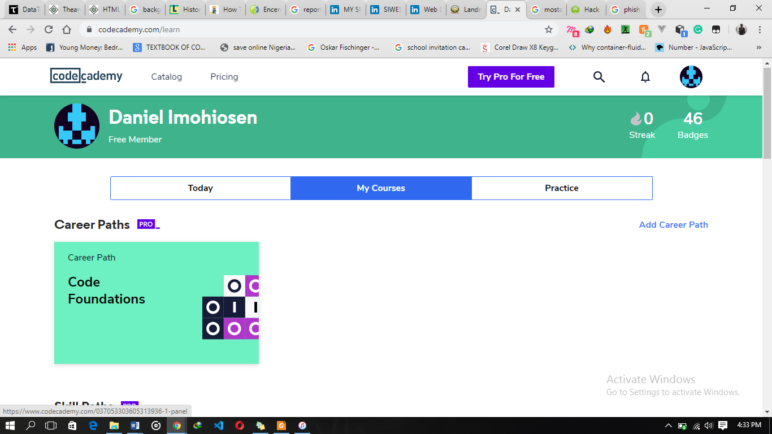

Fig 1.0 showing my account at codeacademy.com

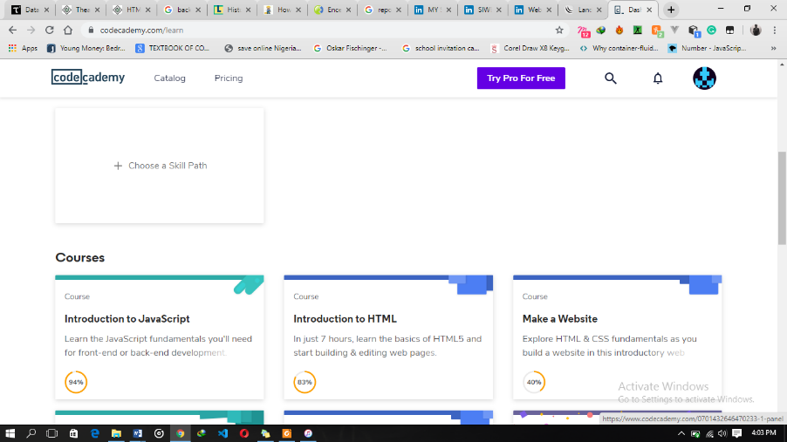

Fig 1.1 showing JavaScript and HTML courses taken at Codeacademy.com

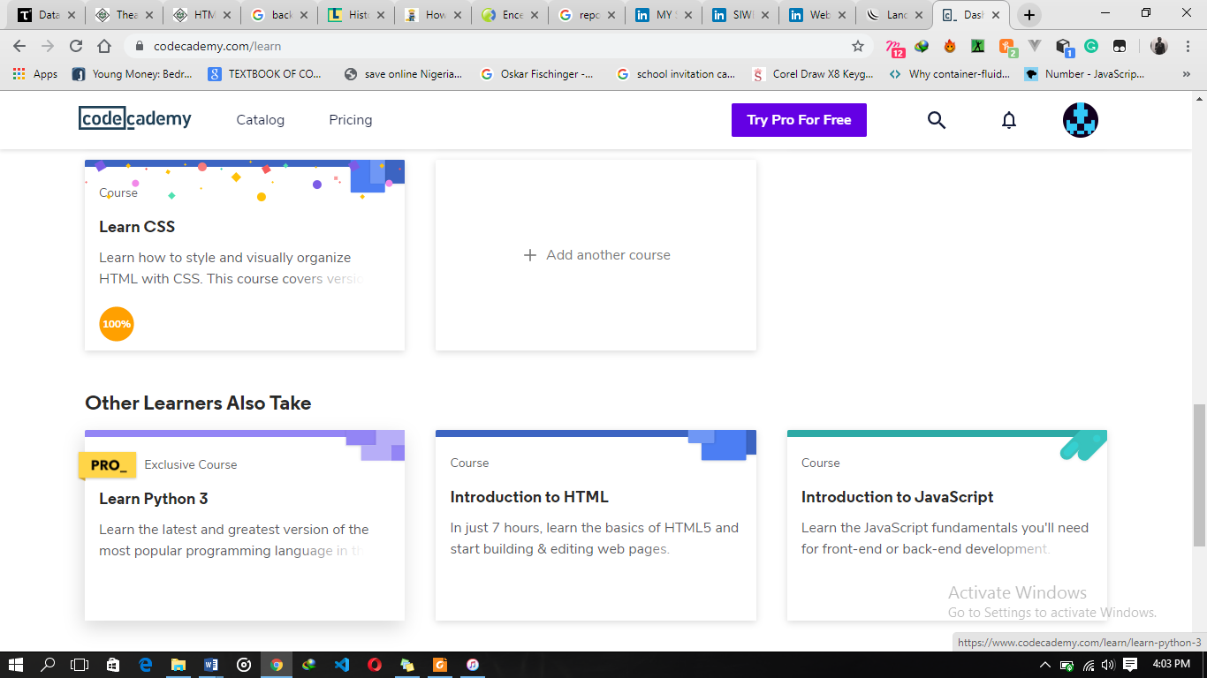

Fig 1.3 showing CSS course taken at Codeacademy.com

I took secondary tutorials and guides from other websites including – tutorialspoint.com, w3schools.com, stackoverflow.com etc.

* 1. **DEFINITION OF TERMS**

The following are terms that were made use of along my learning process.

* **WEBSITE:**A website is a set of related webpages containing content such as texts, images,  
  videos, audios, etc. A website is hosted on at least one web server, accessible via a network  
  such as the internet or a private LAN through an internet address known as a URL (Universal  
  Resource Locator). A publicly accessible websites collectively constitutes the World Wide  
  Web (WWW).
* **WEBPAGE:**A webpage is a document, typically written in plain text interspersed with formatting  
  instructions of hypertext nark up language (HTML, XHTML). A webpage may incorporate  
  elements from other websites with suitable anchors. Webpages are accessed and transported with the hypertext transfer protocol (HTTP), which may occasionally employ encryption (HTTP secure, HTTPS) to provide security and privacy for the use of the webpage content. The user’s application often a web browser renders the page content according to its HTML mark-up instructions into a display terminal.
* **HTTP:**This stands for Hyper Text Transfer Protocol which is the set of rules for transferring  
  files (text, graphic, images, sound, video, and other multimedia files) on the World Wide  
  Web.
* **URL:**This stands for Uniform Resource Locator and as the name suggests, it provides a  
  way to locate a resource on the web, the hypertext system that operates over the internet.
  1. **HTML AND ITS PROPERTIES**

HTML stands for Hypertext Mark-up Language, and it is the most widely used  
language to write Web Pages.

* Hypertext refers to the way in which Web pages (HTML documents) are linked  
  together. Thus, the link available on a webpage is called Hypertext.
* As its name suggests, HTML is a Markup Language which means you use HTML  
  to simply "mark-up" a text document with tags that tell a Web browser how to  
  structure it to display.  
  Originally, HTML was developed with the intent of defining the structure of documents like headings, paragraphs, lists, and so forth to facilitate the sharing of scientific information between researchers.  
  Now, HTML is being widely used to format web pages with the help of different tags  
  available in HTML language.
  + 1. **HTML TAGS**

Just as I earlier stated, HTML is a markup language and makes use of various tags to format  
the content. These tags are enclosed within angle braces <Tag Name>. Except few tags, most  
of the tags have their corresponding closing tags. For example, <html>has its closing  
tag</html>and <body>tag has its closing tag </body>tag etc.  
The following are the names of tags and their description.

The following are the names of tags and their description.

|  |  |
| --- | --- |
| **Tag** | **Description** |
| <html> | This tag encloses the complete HTML document and mainly comprises of document header which is represented by <head>...</head> and document body which is represented by <body>...</body> tags. |
| <head> | This tag represents the document's header which can keep other HTML tags like <title>, <link>, <script language =”JavaScript”> etc. |
| <title> | The <title> tag is used inside the <head> tag to mention the document title. |
| <body> | This tag represents the document's body which keeps other HTML tags like <h1>, <div>, <p>, <table> etc. |
| <h1> | This tag represents a heading |
| <p> | This tag represents a paragraph. |
| <b>, <i>, <li>, <ul> | Bold, italic, list, unordered list |

* + 1. **HTML TABLE**

The HTML table model allows web designers to arrange data –text, preformatted text,  
images, links, forms, form fields, other tables, etc. into rows and columns of cells. It is  
defined with the <table> tag.  
Table are divided into table rows with the <tr> tag. Table rows are divided into table  
data with the <td> tag. A table row can also be divided into table headings with the <th> tag.  
Table data <td> are the data containers of the table. They can contain all sorts of HTML  
elements like text, images, lists, other tables. Below is a code view of HTML and CSS.

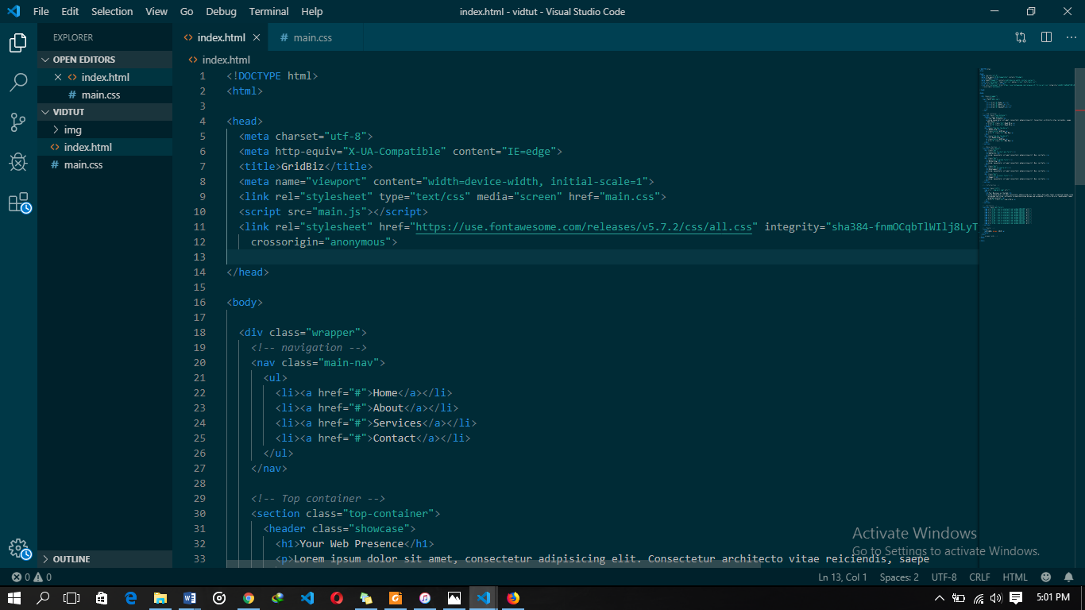

Fig 1.4 Sample code view of HTML in Visual studio code editor.

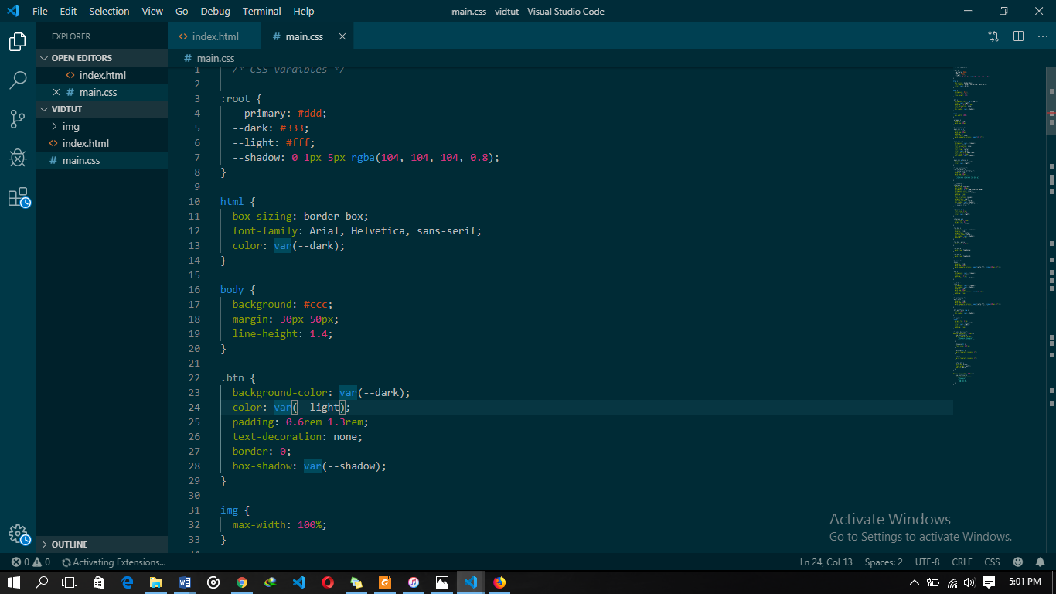

Fig 1.5 Sample code view of CSS in Visual studio code editor.



Fig 1.6 Result of the above sample code in HTML and CSS.

* 1. **CSS AND ITS PROPERTIES**

CSS stands for Cascading Style Sheet used for formatting html document. It is a stylesheet

language used for describing the presentation of a document written in a mark-up language. Note: CSS code is not written the same way as HTML code is.

This makes sense because CSS is not HTML, but rather a way of manipulating existing HTML.

* + 1. **REASONS FOR CSS**

The following are reasons for the use of CSS.

* It saves time.
* It eradicates the idea of using repeating codes.
* It provides efficiency in design and updates: with CSS, we are able to create rules, and  
  apply those rules to many elements within the website.
* It can lead to faster page downloads - since rules are only downloaded once by the  
  browser, then are the cached and used for each page load, the use of CSS can lead to lighter page loads, and improved performance. This contributes to lighter server loads  
  and lower requirements, which overall saves money for our clients.
* It creates external file (server side) for managing html content.
  + 1. **METHODS USED BY CSS IN FORMATTING HTML DOCUMENTS**
* **Inline Style:** It is used to apply a unique style to a single HTML element. An inlineCSS uses the style attribute of an HTML element.
* **Embedded / Internal Style:** It is used if one single page has a unique style. Internalstyles are defined within the <style> element, inside the <head> section of an HTMLpage.
* **External Style:** With an external style sheet, you can change the look of an entirewebsite by changing just one file. Each page must include a reference to the externalstyle sheet file inside the <link> element. The <link> element goes inside the <head>section. Also when using external css it is preferable to keep the css separate fromyour HTML. Placing CSS in a separate file allows the web designer to completelydifferentiate between content (HTML) and design (CSS). External CSS is a file thatcontains only CSS code and is saved with a “.css” file extension. This CSS is thenreferenced in your HTML using the <link> instead of <style> as earlier stated.
  + 1. **VARIOUS CSS SELECTORS AND HOW THEY CAN BE USED**

CSS selectors are used to find or select HTML elements based on their element name, id or class.

* **Element Selector:** The element selector selects elements based on the element name.
* **Id Selector:** The id selector uses the id attribute of an HTML element to select aspecific element. The id of an element should be unique within a page, so the idselector is used to select one unique element. e.g. id=”hello” css #hello { color : red;}.
* **Class Selector:** The class selector selects elements with specific class attribute. Toselect elements with a specific class, write a period (.) character followed by the nameof the class. e.g. .center {text-align:center;}.
  1. **CSS RULES OVERRIDING**
* Any inline style sheet takes the highest priority, so it will override any rule defined in  
  <style>……</style> tags.
* Any rule defined in <style>………</style> tags will override the rules defined in any  
  external style sheet file.
  1. **CSS COMMENTS**

To simply put comment inside a style sheet you use /*………..*/, you can use it to  
comment multi-line blocks in similar way as it is done in C and C++ programming languages.

* 1. **BACKGROUND AND FONT PROPERTIES OF HTML ELEMENTS**

You can set the following background properties of an element.

* **The background-color:** Is a property used to set the color background of an element.
* **The background-image property:** is used to set the background image of anelement.
* **The background repeat:** Is used to control the repetition of an image in thebackground.
* **The background position:** Is used to control the position of an image in thebackground.
* **The background attachment:** Is used to control the scrolling of an image in thebackground.
* **The background property:** Is used as a short hand to specify a number of otherbackground properties.
  + 1. **FONT PROPERTIES**
* **The Font-family property:** This is used to change the face of a font
* **The Font-style property:** This is used to make a font italic or oblique.
* **The Font-weight property:** This is used to increase or decrease how bold or light afont appears.
* **The Font-size property:** This is used to increase or decrease the size of a font.
  + 1. **TEXT DECORATION**This demonstrate how to decorate a text in CSS, the values are none, underline, overline, line through and blink.
    2. **PROPERTIES OF HYPERLINK USING CSS**

1. The link signifies unvisited hyperlinks.
2. The link visited signifies visited hyperlinks.
3. The link hovered signifies an element that currently has the user’s mouse pointerhovering over it.
4. The link active signifies an element on which the user is currently clicking.
   1. **JAVASCRIPT AND ITS PROPERTIES**JavaScript is a dynamic computer programming language. It is lightweight and mostcommonly used as a part of web pages, whose implementations allows client side script tointeract with the user and make dynamic pages. It is an interpreted programming languagewith object oriented capabilities. It was developed by Brenan Eich. 1995-1996; it is animplementation of ECMA Script (European Computer Manufacturers Association). It wasalso known as livescript later change to JavaScript. It is use for client side web formvalidation. JavaScript cannot run with been embedded in the HTML.
      1. **FUNCTIONS OF JAVASCRIPT  
         1.** It is most commonly used as a client side scripting language, which implies thatJavaScript is written into an HTML page and when a user request an HTML page withJavaScript in it, the script is sent to the browser. **2.** It used for form validation.
      2. **BROWSER DETECTION**This refers to a feature of a web browser to execute a JavaScript code without anyerror irrespective of its version.
      3. **ADVANTAGES OF JAVASCRIPT**

* **Less server interaction:** You can validate user input before sending the page off tothe server. This saves server traffic, which means fewer loads on your server.
* **Immediate feedback to the visitors:** They don’t have to wait for a page to reload tosee if they forgotten to enter something.
* **Increased interactivity:** You can create interfaces that react when the user hoversover them with a mouse or activates them via the keyboard.
* **Richer interfaces:** You can use JavaScript to include such items as drag and dropcomponent and sliders to give a rich interface to your site visitors.
  + 1. **JAVASCRIPT DEVELOPMENT TOOLS**

One of the major strengths of JavaScript is that it does not require expensivedevelopment tools. One can begin with a simple text editor such as notepad or notepad++.Since it is an interpreted language inside the context of a web browser, you don’t even needto buy a compiler.However to make life simpler, various vendors have come up with very niceJavaScript editing tools, they are macromedia Dreamweaver.

* + 1. **JAVASCRIPT SYNTAX**JavaScript can be implemented using JavaScript statements that are placed within the<script>…………..</script> HTML tags in a web page. You can place the <script> tags,containing your JavaScript, anywhere within your web page, but it is normally recommendedthat we should keep it within the <head> tags.The script tag takes two important attributes: **1. Language:** This attribute specifies what scripting language i am using. **2. Type:** This attribute is what is now recommended to indicate the scripting language inuse and its value should be set to “text/JavaScript”.
    2. **COMMENTS IN JAVASCRIPT**JavaScript supports both c-style and c++ style comments. Thus: **1.** Any text between a // and the end of a line is treated as a comment and is ignored byJavaScript. **2.** Any text between the characters /* and */ is treated as a comment. This may spanmultiple lines. **3.** JavaScript also recognizes the HTML comment opening sequence <! --. JavaScripttreats this as a single-line comment, just as it dos the //comment. **4.** The HTML comment closing sequence --!> is not recognized by JavaScript so itshould be written as //-->
    3. **DATA TYPES IN JAVASCRIPT**One of the most fundamental characteristics of a programming language is the set ofdata types it support. These are the type of values that can be represented and manipulated ina programming language. They include:
* **Numbers:** This represents numeric values e.g. 100.
* **Strings:** This represents sequence of character e.g. Hello.
* **Boolean:** This represents Boolean value either true or false
* **Null:** This represents nothing i.e. it can be empty.
* **Undefined:** This represents undefined values.
* **Object:** This represent values return by functions.
  1. **JAVASCRIPT VARIABLES**This is a memory location used for holding values or used for storing values in amemory. **var** (keyword) is used to hold a value or declare a value, it makes it known to acompiler, interpreter.E.g. var name ----- DeclarationName = “Jonathan” ----- Initialization
     1. **VARIABLE NAMES**While naming the variables in JavaScript, the following rules should be keptin mind. **•** You should not use any of the JavaScript reserved keywords as a variablename. For example, **break or boolean  
        •** JavaScript variable names should not start with a numeral (0-9). They mustbegin with a letter or an underscore character. For example, **455daniel** is aninvalid name but **_556daniel, daniel** is a valid one. **•** JavaScript variable names are case-sensitive. For example, **Daniel** and **ejiro** aretwo different variables.
  2. **OPERATORS**Let me take a simple expression to give its meaning 4 + 5 = 9. Here 4 and 5 are called  
     operands and “+” is called the operator. JavaScript support the following types of operators  
     they are:

1. **Arithmetic Operators:** JavaScript supports the following arithmetic operators usingan expression. Assume variable A holds 10 and variable B holds 20, then **a. Addition (+) e.g.** A + B = 30 **b. Subtraction (-) e.g.** A – B = -10 **c. Multiplication (*) e.g.** A * B = 200 **d. Division (/) e.g.** B/A = 2 **e. Modulus (%) e.g.** B%A = 0 **f. Increment (++) e.g.** A++ = 11 **g. Decrement (--) e.g.** A-- = 9
2. **Comparison Operators:** JavaScript support the following comparison operators.Assume variable A holds 10 and variable B holds 20, then; **a. Equal (==):** Checks if the value of two operands are equal or not, if yes, thenthe condition becomes true. **e.g.** (A == B) is not true. **b. Not Equal (!=):** Checks if the value of two operands are equal or not, if thevalues are not equal, then the condition becomes true. **e.g.** (A != B) is true. **c. Greater Than (>):** Checks if the value of the left operand is greater than thevalue of the right operand, if yes, then the condition becomes true. **e.g.** (A > B)is not true. **d. Less Than (<):** Checks if the value of the left operand is less than the value ofthe right operand, if yes, then the condition becomes true. **e.g.** (A < B) is true. **e. Greater Than or Equal To (>=):** Checks if the value of the left operand isgreater than or equal to the value of the right operand, if yes, then thecondition becomes true. **e.g. (A >= B)** is not true.

**f. Less Than or Equal To (<=):** Checks if the value of the left operand is lessthan or equal to the value of the right operand, if yes, then the conditionbecomes true. **e.g. (**A <= B) is true.

1. **Logical (or Relational) Operators:** JavaScript supports the following logicaloperators. Assume variable A holds 10 and variable holds 20, then; **a. Logical AND (&&):** If both the operands are non-zero, then the conditionbecomes true. **e.g.** (A && B) is true. **b. Logical OR (||):** If any of the two operands are non-zero, then the conditionbecomes true. **e.g.** (A || B) is true. **c. Logical NOT (!):** Reverses the logical state of its operand. If a condition istrue, the logical NOT operator will make it false. **e.g.** !(A && B) is false.
2. Assignment Operators
3. Conditional Operators
   1. **SELECTION STATEMENTS**When writing a program, there may be a situation when we need to adopt one out of agiven set of paths. In such cases, conditional statement is used which allows our programto make correct decisions and perform right actions. The following selection statements aresupported by JavaScript are:

**1. IF STATEMENT:** This is the fundamental control statement that allows JavaScriptto make decisions and execute statements conditionally.

**2. IF-ELSE STATEMENT:** This is the next form of the selection statement that allowsJavaScript to execute statements in a more controlled way.

**3. IF-ELSE-IF STATEMENT:** This is an advanced form of if else that allowsJavaScript to make a correct decision out of several conditions.

**4. SWITCH CASE:** Switch case is used to handle situation more efficiently thanrepeated **if-else-if** statements.

* + 1. **LOOP STATEMENT**While writing a program, you may encounter a situation where you need to performan action over and over again. In such situations, you would need to write loop statements toreduce the number of lines. JavaScript supports all the necessary loops to ease down thepressure of programming.

1. **WHILE LOOP:** The purpose of a while loop is to execute a statement or code blockrepeatedly as long as an expression is true. Once the expression becomes **false,** theloop terminates.
2. **DO WHILE LOOP:** This is similar to the **while loop** except that the conditionchecks what happens at the end of the loop. This means that the loop will always beexecuted at least once, even if the condition if false.
3. **FOR LOOP:** This is the most compact form of looping. It includes the followingthree (3) important parts: **• Loop Initialization** where we initialize our counter to a starting value. Theinitialization statement is executed before the loop begins. **• Test statement** which will test if a given condition is true or not. If thecondition is true, then the code given inside the loop will be executed,otherwise the control will come out of the loop. **• Iteration statement** where you can increase or decrease your counter. **Note:** All this three (3) parts are inserted in a single line separated bysemicolons.
   1. **FUNCTIONS**A function is a group of reusable code which can be called anywhere in your program.  
      This eliminates the need of writing the same code again and again. It helps programmers in writing modular codes. It allows a programmer to divide a big program into a number of small and manageable functions. Before we use a function, we need to define it. The most common way to define a function in JavaScript is by using the function keyword followed by a unique function name, a list of parameters (this might be empty), and a statement block surrounded by curly braces. Also to invoke a function somewhere later in the script, you would simply need to write the name of that function.
   2. **VUE.js (JavaScript Framework)**

**VueJS** is an open source progressive JavaScript framework used to develop interactive web interfaces. It is one of the famous frameworks used to simplify web development. VueJS focusses on the view layer. It can be easily integrated into big projects for front-end development without any issues.

The installation for VueJS is very easy to start with. Any developer can easily understand and build interactive web interfaces in a matter of time. VueJS is created by Evan You, an ex-employee from Google. The first version of VueJS was released in Feb 2014. It recently has clocked to 64,828 stars on GitHub, making it very popular.

* + 1. **Features of VueJs**

Following are the features available with VueJS.

* **Virtual DOM**

VueJS makes the use of virtual DOM, which is also used by other frameworks such as React, Ember, etc. The changes are not made to the DOM, instead a replica of the DOM is created which is present in the form of JavaScript data structures. Whenever any changes are to be made, they are made to the JavaScript data structures and the latter is compared with the original data structure. The final changes are then updated to the real DOM, which the user will see changing. This is good in terms of optimization, it is less expensive and the changes can be made at a faster rate.

* **Data Binding**

The data binding feature helps manipulate or assign values to HTML attributes, change the style, assign classes with the help of binding directive called **v-bind** available with VueJS.

* **Components**

Components are one of the important features of VueJS that helps create custom elements, which can be reused in HTML.

* **Event Handling**

**v-on** is the attribute added to the DOM elements to listen to the events in VueJS.

* **Animation/Transition**

VueJS provides various ways to apply transition to HTML elements when they are added/updated or removed from the DOM. VueJS has a built-in transition component that needs to be wrapped around the element for transition effect. We can easily add third party animation libraries and also add more interactivity to the interface.

* **Computed Properties**

This is one of the important features of VueJS. It helps to listen to the changes made to the UI elements and performs the necessary calculations. There is no need of additional coding for this.

* **Templates**

VueJS provides HTML-based templates that bind the DOM with the Vue instance data. Vue compiles the templates into virtual DOM Render functions. We can make use of the template of render functions and to do so we have to replace the template with the render function.

* **Directives**

VueJS has built-in directives such as v-if, v-else, v-show, v-on, v-bind, and v-model, which are used to perform various actions on the frontend.

* **Watchers**

Watchers are applied to data that changes. For example, form input elements. Here, we don’t have to add any additional events. Watcher takes care of handling any data changes making the code simple and fast.

* **Routing**

Navigation between pages is performed with the help of vue-router.

* **Lightweight**

VueJS script is very lightweight and the performance is also very fast.

* **Vue-CLI**

VueJS can be installed at the command line using the vue-cli command line interface. It helps to build and compile the project easily using vue-cli.

**WEBSITE DESIGN USING HTML, CSS, JavaScript AND VueJs**

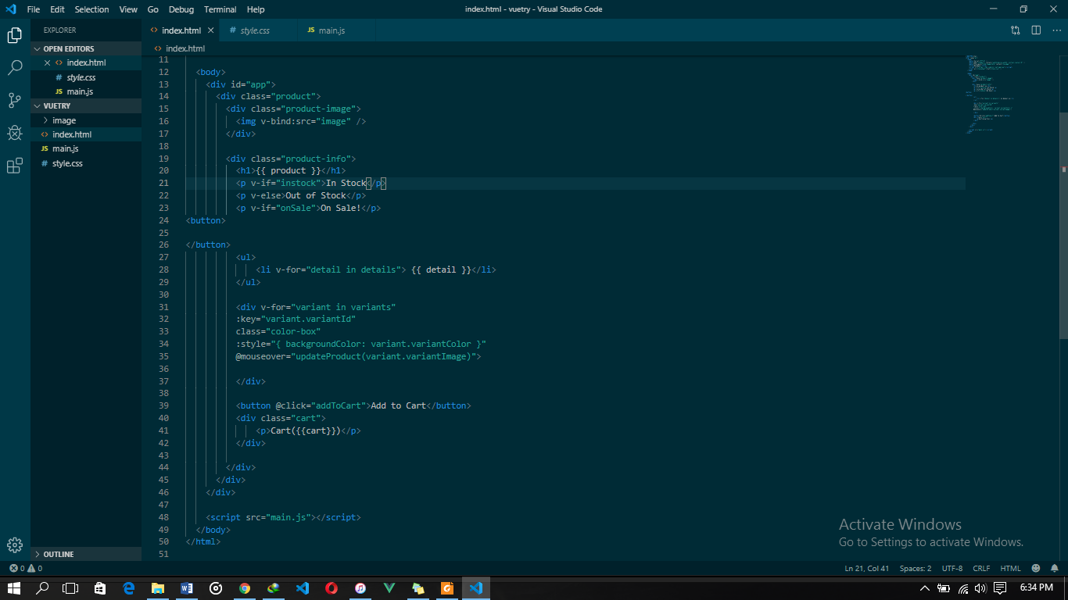

**Fig 1.7** Showing HTML code of sample site

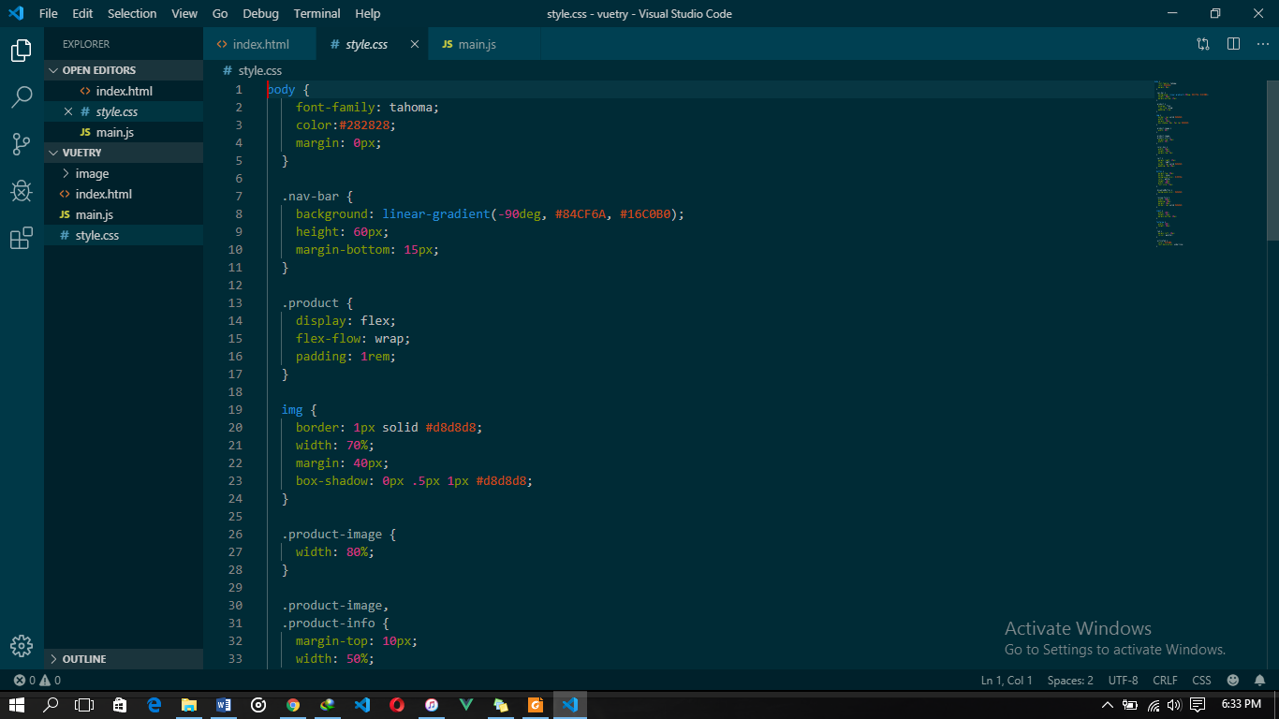

Fig 1.8 Showing the CSS code of sample site

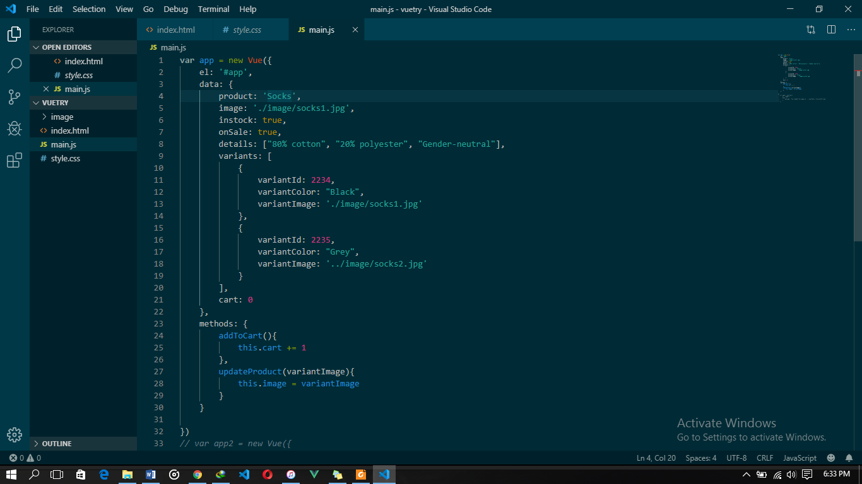

Fig 1.9 Showing the JavaScript and VueJs code of sample site

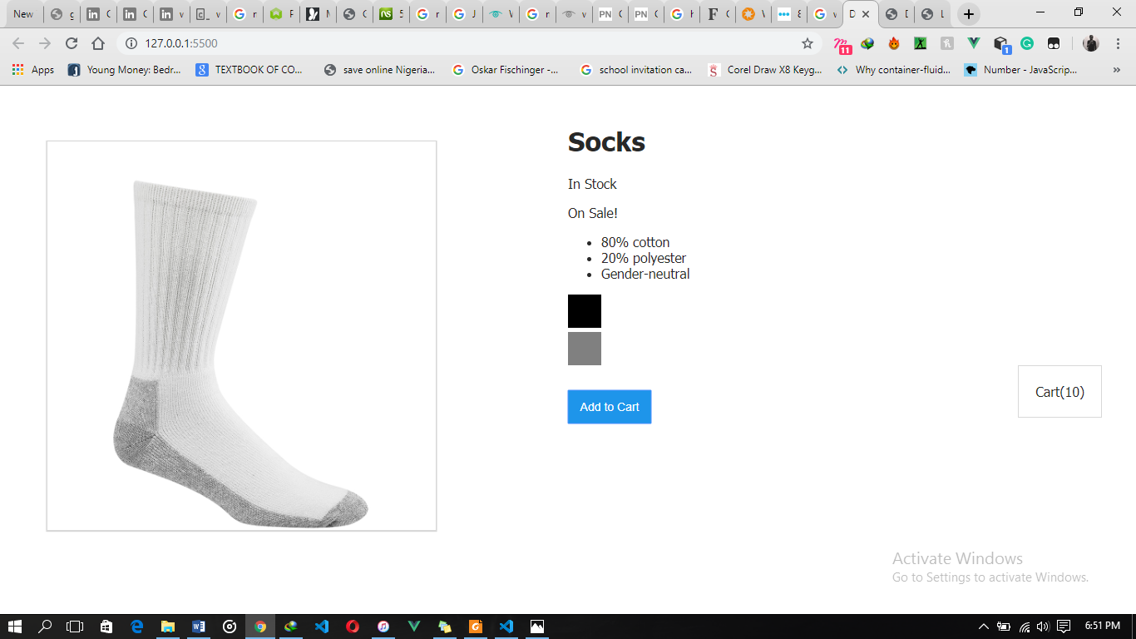

Fig 2.0 Showing Final Output of sample site.

**EXPERIENCE GAINED**

During my time at Encentral Solutions I worked on some sample projects as to monitor my personal progress at every point in time. Some other projects were instigated by Encentral Solutions. Some of this projects which include;

1. CSS Grid system prototype

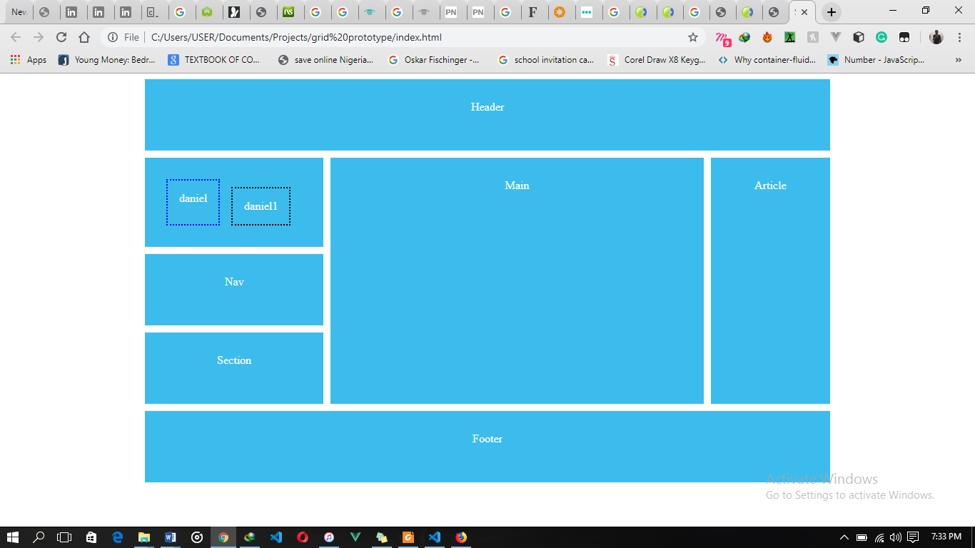

1. Dummy Site from W3schools.com



1. Prototype Website for Encentral Solutions.



**CHAPTER THREE**

**PROBLEMS ENCOUNTERED AND PROBLEMS SOLVED**

* 1. **Problems Encountered**

During the time I spent at Encentral Solutions, I encountered some challenges and learning new things can’t be without challenges, such challenges I encountered are;

1. Difficulties while trying to get a SIWES placement.
2. Initially had troubles getting to work early as I was unfamiliar with the new routes, till I found faster routes.
3. While trying to source for information online, I frequently experienced slow internet service.
4. Difficulty in understanding how to go about new concepts of study.
5. Lack of proper SIWES student orientation.
6. Getting used to the work/office way of life.
7. Taking accurate minutes of meetings while on training at foreign companies.
8. Not getting paid at any point throughout the SIWES period.
9. Problem of stable electricity on some days, added with the fact that my laptop developed a battery problem at a certain point in time.
10. Problem with searching for answers to problems relating to my line work, using the right keywords.
11. Meeting some work deadlines.
    1. **PROBLEMS SOLVED**

Providing solutions to some of the listed problems encountered, I tried to get familiar with faster routes to get to work, also I got a personal Wi-Fi for better internet experience and watched a great number of tutorials to better understand concepts that I didn’t understand. Moreover, I asked my supervisor for guidance on things that were initially hard to grasp and I tried to get familiar with the office environment and how to function better when I was present.

**CHAPTER FOUR**

**SUMMARY, CONCLUSIONS AND RECOMMENDATIONS.**

* 1. **Summary and Conclusion**

Conclusively, a bachelor degree in Computer Science would not be complete without this SIWES training. SIWES as a whole teaches you what you cannot learn in the confines of a classroom. It made me understand the practical applications of most concepts explained in school, taught me how to work under pressure and made me more aware of the frequent changes and improvements in the world of science and technology.

Through the Students Industrial Work Experience Scheme (SIWES) which I carried out at Encentral Solutions I gained a hand-full of knowledge on Office Management, Customer relations and I was generally exposed to real life working experience – carrying out office tasks, making suggestions/contributions in order to make the office move forward on certain challenging issues, carrying out maintenance and testing on Applications created by the company etc.

However, this program has given me a greater mindset towards life and what to look out for in the labor market after school and has exposed me to the reality of life and how to make the best out of it with the resources available to me.

* 1. **Recommendations**
* Schools should make plans aimed at assisting students’ who have no means of getting a placement for their internship program to prevent wastage of time and achieving nothing as he/she goes from place to place in search of a SIWES placement.
* Organization should be encouraged to give interns more responsibilities and challenges especially in aspects that will be of benefit to them in skills acquisition.
* University Supervisors should always visit students monthly in their various places of attachment so as to be able to track the students’ progress better.

Additionally, I would recommend that this SIWES programme should not be limited to the sciences only, but should be extended even to the non-sciences as it would also help them.